

# *UniX and Linux Essentials*

**ASSIGNMENT – 8.1**

**SUBMITTED BY:**

**AYUSH KUMAR JHA**

**SAP ID - 500086400**

**Enrollment no - R200220083**

**B.C.A -I.O.T.**

**Assignment 8.1: -**

**Redirection:-**

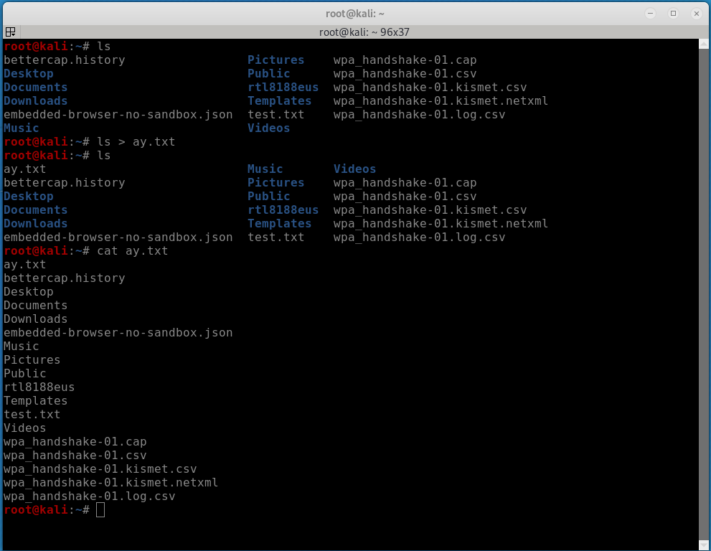

Appens case :-

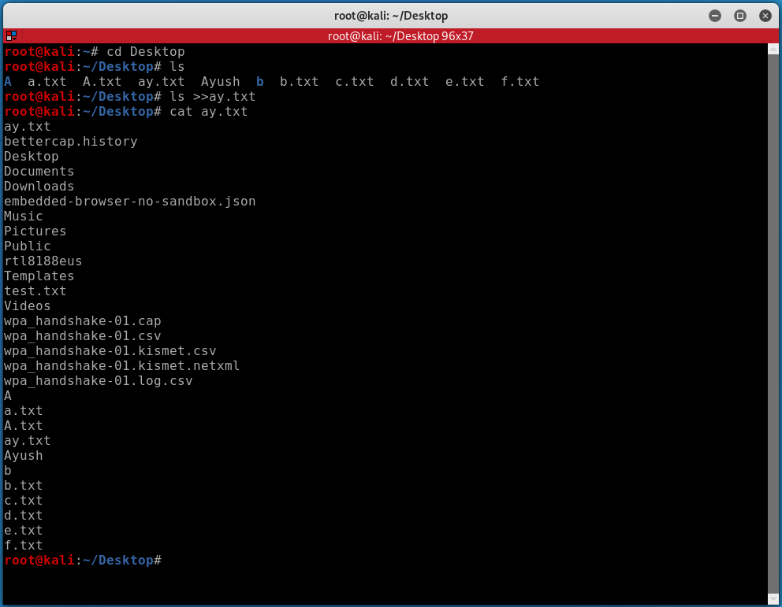

Pipe and tee :-

